GS - CyberSecurity

Integrantes
RM556803 - Eduardo Dallabella Lima
RM558468 - Abner de Paiva Barbosa
RM554535 - Heloísa Leal
RM550494 - Mariana Neugebauer Dourado
RM554746 - Beatriz Vieira de Novais

1. Identificação de Riscos e Ameaças

2. Definição de Controles de Segurança (Arquitetura Enxuta)
Os controles de segurança escolhidos foram:
Criptografia de dados sensíveis:
Segurança para IoT (autenticação, comunicação segura)
Backup e política de recuperação
Monitoramento básico de logs
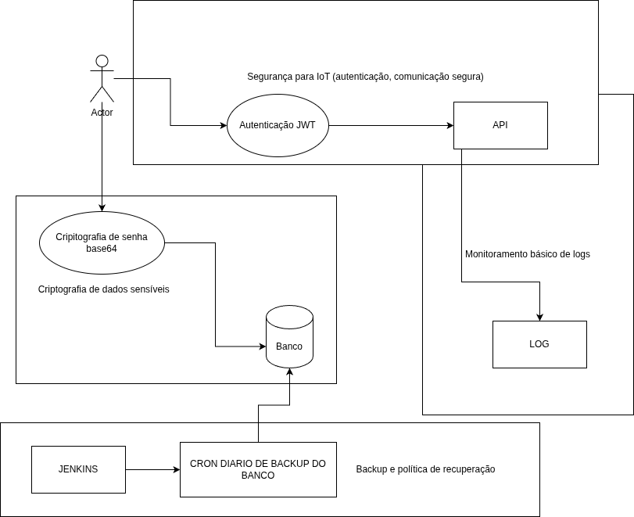

3. Pequena Implementação Prática (Hands-on)
Base do terceiro ponto do PDF: pequena implementação prática real, com evidências de execução, trechos de código e logs.
Opção escolhida: criar um script de backup automatizado para o banco PostgreSQL do Orbital Academy, executado por pipeline Jenkins.
Conexão com o projeto
No Orbital Academy, o banco PostgreSQL sustenta a API principal do MVP. O backup automatizado aumenta a continuidade da solução, preserva evidências para auditoria e ajuda a manter disponíveis os dados usados pela missão agro e pela tomada de decisão baseada no ecossistema espacial.

Print:

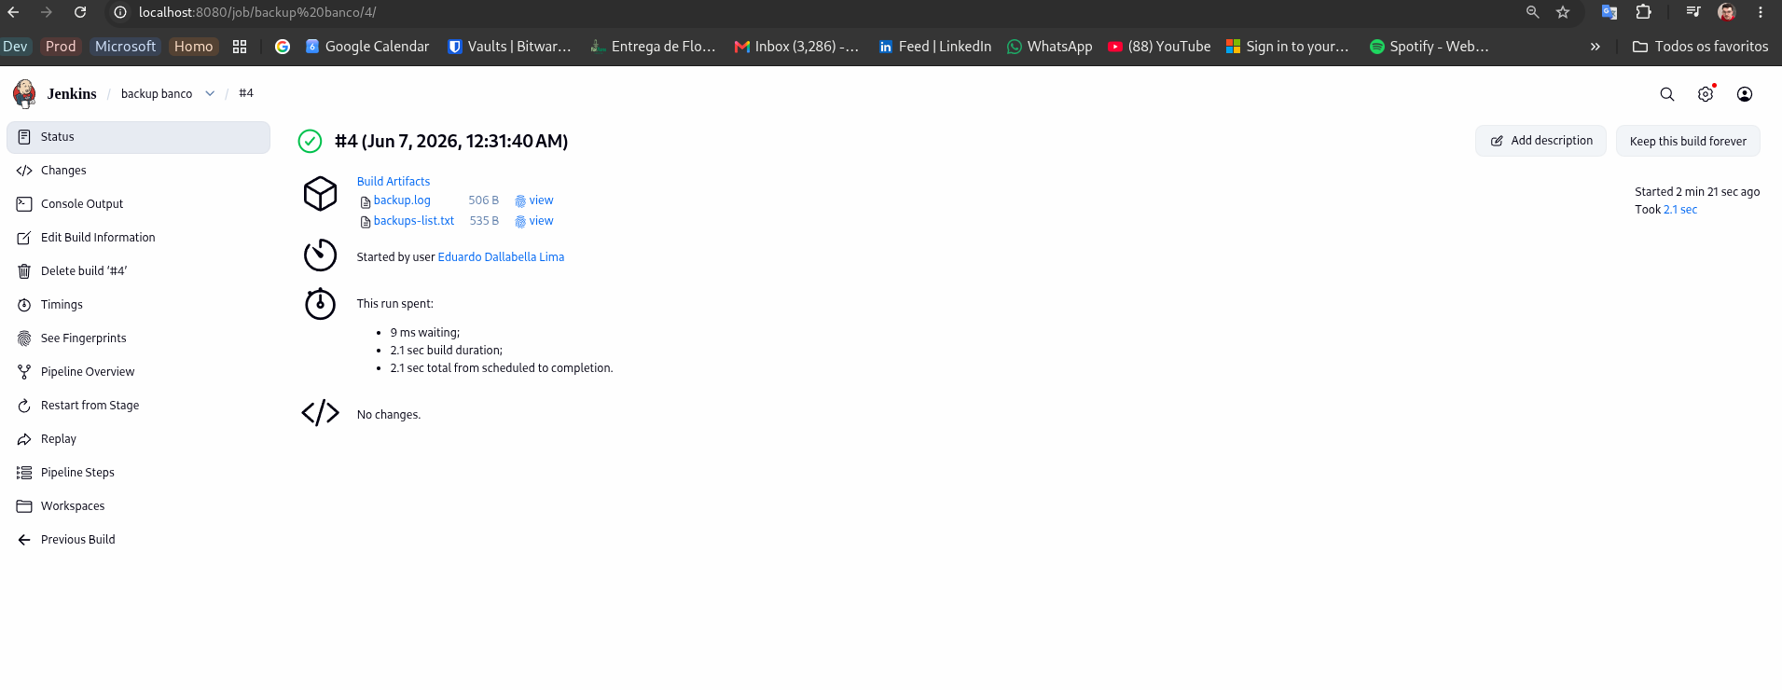
Console:
Started by user Eduardo Dallabella Lima

[Pipeline] Start of Pipeline
[Pipeline] node
Running on Jenkins
in /var/jenkins_home/workspace/backup banco
[Pipeline] {
[Pipeline] withEnv
[Pipeline] {
[Pipeline] timestamps
[Pipeline] {
[Pipeline] stage
[Pipeline] { (Validate environment)
[Pipeline] sh
21:31:40 + set -eu
21:31:40 + test -f scripts/backup-db.sh
21:31:40 + chmod +x scripts/backup-db.sh
21:31:40 + command -v pg_dump
21:31:40 + : postgres
21:31:40 + : 5432
21:31:40 + : orbital_academy
21:31:40 + dirname /backups/logs/backup.log
21:31:40 + mkdir -p /backups /backups/logs
[Pipeline] withCredentials
21:31:40 Masking supported pattern matches of $PGPASSWORD
[Pipeline] {
[Pipeline] sh
21:31:41 + set -eu
21:31:41 + : ****
21:31:41 + : ****
[Pipeline] }
[Pipeline] // withCredentials
[Pipeline] }
[Pipeline] // stage
[Pipeline] stage
[Pipeline] { (Run database backup)
[Pipeline] withCredentials
21:31:41 Masking supported pattern matches of $PGPASSWORD
[Pipeline] {
[Pipeline] sh
21:31:41 + set -eu
21:31:41 + scripts/backup-db.sh
21:31:41 Backup gerado: /backups/****_academy_20260607_003141.dump
[Pipeline] }
[Pipeline] // withCredentials
[Pipeline] }
[Pipeline] // stage
[Pipeline] stage
[Pipeline] { (Archive evidences)
[Pipeline] sh
21:31:41 + set -eu
21:31:41 + rm -rf jenkins-evidence
21:31:41 + mkdir -p jenkins-evidence
21:31:41 + [ -f /backups/logs/backup.log ]
21:31:41 + cp /backups/logs/backup.log jenkins-evidence/backup.log
21:31:41 + echo Backup directory: /backups
21:31:41 + ls -la /backups
21:31:41 + echo
21:31:41 + echo Backup logs:
21:31:41 + dirname /backups/logs/backup.log
21:31:41 + ls -la /backups/logs
[Pipeline] archiveArtifacts
21:31:41 Archiving artifacts
21:31:41 Recording fingerprints
[Pipeline] }
[Pipeline] // stage
[Pipeline] stage
[Pipeline] { (Declarative: Post Actions)
[Pipeline] sh
21:31:42 + [ -f /backups/logs/backup.log ]
21:31:42 + tail -n 20 /backups/logs/backup.log
21:31:42 2026-06-07T00:24:38Z | status=ERROR | file=orbital_academy_20260607_002438.dump | exit_code=0 | message=falha ao executar pg_dump
21:31:42 2026-06-07T00:26:03Z | status=ERROR | file=orbital_academy_20260607_002603.dump | exit_code=1 | message=falha ao executar pg_dump
21:31:42 2026-06-07T00:26:44Z | status=SUCCESS | file=orbital_academy_20260607_002644.dump | exit_code=0 | message=backup concluido
21:31:42 2026-06-07T00:31:41Z | status=SUCCESS | file=orbital_academy_20260607_003141.dump | exit_code=0 | message=backup concluido
[Pipeline] }
[Pipeline] // stage
[Pipeline] }
[Pipeline] // timestamps
[Pipeline] }
[Pipeline] // withEnv
[Pipeline] }
[Pipeline] // node
[Pipeline] End of Pipeline
Finished: SUCCESS

Confirmação do backup:
eduardo@eduardo:~/Documentos/projetos-eduardo/orbital-academy-service$ docker exec agitated_cerf pg_restore --list /backups/orbital_academy_20260607_003141.dump | head
;
; Archive created at 2026-06-07 00:31:41 UTC
; dbname: orbital_academy
; TOC Entries: 11
; Compression: gzip
; Dump Version: 1.16-0
; Format: CUSTOM
; Integer: 4 bytes
; Offset: 8 bytes
; Dumped from database version: 18.4 (Debian 18.4-1.pgdg13+1)

URL Projeto:
https://github.com/OrbitalAcademy/orbital-academy-service/tree/feature/2026/06/backup-banco-cyber

